Data Structure
Structured Data:
- This type of data is very organized and follows a specific format or structure. Think of it like a well-organized filing cabinet where everything is labeled and easy to find. Examples include data in tables like in databases, spreadsheets, or CSV files where each piece of information is neatly arranged in rows and columns.
Semi-Structured Data:
- Semi-structured data has some organization but isn't as rigid as structured data. It's like a book with chapters and sections that follow a certain pattern, making it easier to understand. An example is an XML file, where data is organized with tags but doesn't fit neatly into tables.
Unstructured Data:
- Unstructured data is like a messy drawer where things are just thrown in without any order. It doesn't have a specific format or structure, making it harder to analyze. Examples include text documents, images, videos, or PDFs where information is all over the place and doesn't follow a set pattern.

Data Preprocessing
Data preprocessing is a crucial step in the data analytics process that involves transforming
raw data into a clean and usable format. This process ensures that the data is of high quality,
free from errors, and ready for analysis. Below is an overview of the key aspects of data
preprocessing:
Major Tasks in Data Preprocessing
Data preprocessing involves several major tasks that are essential for preparing data for
analysis:
• Data Cleaning: Removing or correcting errors, inconsistencies, and missing values.
• Data Integration: Combining data from multiple sources into a cohesive dataset.
• Data Reduction: Reducing the volume of data while maintaining its integrity.
• Data Transformation: Modifying data to fit the requirements of the analysis,
including normalization and aggregation.
• Data Discretization: Converting continuous data into discrete intervals or categories.

Example: When preparing data from various departments of a company, each task ensures
that the final dataset is ready for accurate and insightful analysis.
Why data preprocessing is required?
Data quality is a critical factor in data-driven decision-making processes. High-quality data
must meet specific requirements based on the intended use, ensuring that the insights derived
from it are reliable and actionable. To evaluate and ensure data quality, we consider several
dimensions.

Data Cleaning is the process of detecting and correcting errors or inconsistencies in the data
to improve its quality.
Key steps include:
• Handling Missing Data: Filling in missing values with appropriate estimates, or
removing records with too many missing fields.
• Removing Duplicates: Identifying and eliminating duplicate records that can skew
analysis results.

• Correcting Errors: Fixing typographical errors, correcting misformatted data, and
standardizing data entries.
Example: In a sales database, if the revenue column has some entries as &quot;N/A&quot; or
negative values, data cleaning would involve correcting these errors to ensure
accurate sales reporting.

Handling missing values is a critical step in preparing data for classification tasks. Here's a breakdown of several approaches, explained in simple terms:

1. **Ignore the Tuple**
- **What it Means**: If a data point (or row) is missing a class label or important information, we can skip or remove the entire row from our dataset.
- **When to Use**: This method works well if only a small portion of the data is missing. However, if many attributes have missing values, it can result in a loss of valuable data, reducing the quality of the dataset.

2. **Fill in the Missing Value Manually**
- **What it Means**: Manually inspecting and filling missing values by hand.
- **Challenges**: This method is time-consuming and impractical for large datasets or when there are too many missing values.

3. **Fill in the Missing Values Automatically**
Several automated techniques can be used to handle missing values, including:

- **Using a Global Constant**:
- **What it Means**: Replace all missing values with a single constant, like "unknown" or "N/A."
- **Example**: In a customer review dataset, if age is missing, you can fill in all missing ages with "unknown."
- **Challenges**: This might introduce a new category or class, which can affect analysis or skew results.

- **Using the Attribute Mean**:
- **What it Means**: Replace the missing value with the average of that attribute across all data points.
- **Example**: If the average customer age is 30, fill in missing ages with 30.
- **Challenges**: This method is simple but might be inaccurate, especially in cases of high variability in the data.

- **Using the Attribute Mean for the Same Class**:
- **What it Means**: Use the average value of the missing attribute, but only from data points in the same class (category).
- **Example**: If customers who bought a product ("yes" class) have an average age of 35, fill missing ages with 35 for customers in the "yes" category.
- **Advantages**: This method is more accurate than using the overall average since it accounts for the class context.

- **Using the Most Probable Value**:
- **What it Means**: Use predictive techniques like decision trees or the Bayesian formula to estimate the most likely value for the missing data.
- **Example**: Based on other attributes like income, education, or job type, you can predict the missing age using patterns from the data.
- **Advantages**: This is a more sophisticated and accurate approach, as it considers relationships between different attributes.

In summary, the best method for handling missing values depends on the dataset size, the amount of missing data, and the need for accuracy. Simpler methods (like filling with a mean) are easier to apply, while more advanced methods (like predicting values) offer better accuracy but require more computational resources.

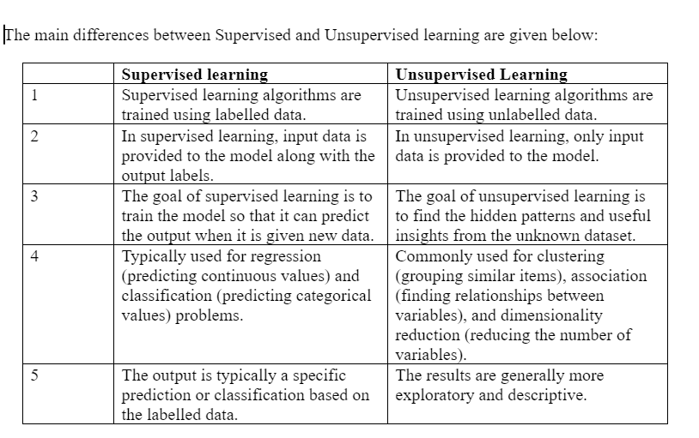
Supervised Machine Learning:
Supervised learning is a machine learning method in which models are trained using labelled data. In supervised learning, models need to find the mapping function to map the input variable (X) with the output variable (Y).
Supervised learning needs supervision to train the model, which is similar to as a student learns things in the presence of a teacher. Supervised learning can be used for two types of problems: Classification and Regression.
Example: Suppose we have an image of different types of fruits. The task of our supervised learning model is to identify the fruits and classify them accordingly. So to identify the image in supervised learning, we will give the input data as well as output for that, which means we will train the model by the shape, size, color, and taste of each fruit. Once the training is completed, we will test the model by giving the new set of fruit. The model will identify the fruit and predict the output using a suitable algorithm.

Unsupervised Machine Learning:
Unsupervised learning is another machine learning method in which patterns inferred from the unlabelled input data. The goal of unsupervised learning is to find the structure and patterns from the input data. Unsupervised learning does not need any supervision. Instead, it finds patterns from the data by its own.
Unsupervised learning can be used for two types of problems: Clustering and Association.
Example: To understand the unsupervised learning, we will use the example given above. So unlike supervised learning, here we will not provide any supervision to the model. We will just provide the input dataset to the model and allow the model to find the patterns from the data. With the help of a suitable algorithm, the model will train itself and divide the fruits into different groups according to the most similar features between them.
Again, suppose there is a basket and it is filled with some fresh fruits. The task is to arrange the same type of fruits in one place. This time there is no information about those fruits beforehand, it’s the first time that the fruits are being seen or discovered So how to group similar fruits without any prior knowledge about them? First, any physical characteristic of a particular fruit is selected. Suppose colour. Then the fruits are arranged based on the color.
The groups will be something as shown below:

What is variable?
Variables are the characteristics or properties that are recorded for each individual or object in a study or dataset. They represent the different attributes or pieces of information that we collect to understand, analyze, and draw conclusions about the data.

Variables can be quantitative (numeric) or qualitative (categorical).
Quantitative Variables
These variables represent numerical values that can be measured or counted. They are further divided into two types: discrete and continuous.
- Discrete Variables: These are countable numbers, typically integers, with distinct or separate values.
  - Example:
    - Number of Children: A variable named "Number of Children" records how many children each family has. Possible values might be 0, 1, 2, 3, etc.
    - Number of Courses Taken: A variable named "Courses_Taken" records how many courses a student is enrolled in. Possible values might be 1, 2, 3, etc.
- Continuous Variables: These represent measurable quantities and can take any value within a given range.
  - Example:
    - Height: A variable named "Height" records the height of each person in centimeters or inches (like 170.5 cm, 162.3 cm, etc.).
    - Weight: A variable named "Weight" records the weight of each person in kilograms or pounds (like 60.5 kg, 72.8 kg, etc.).

2. Qualitative (Categorical) Variables
These variables represent categories or labels and are used to describe non-numerical attributes or qualities. They can be either nominal (no specific order) or ordinal (having a specific order).
- Nominal Variables: These are variables with categories that do not have an inherent order.
  - Example:
    - Gender: A variable named "Gender" records whether each person is "Male" or "Female."
    - Favorite Color: A variable named "Favorite_Color" records a person's favorite color (like "Red," "Blue," "Green," etc.).
- Ordinal Variables: These are categorical variables where the categories have a specific order or ranking.
  - Example:
    - Education Level: A variable named "Education_Level" records the highest level of education each person has completed ("High School," "Undergraduate," "Graduate," etc.).
Satisfaction Rating: A variable named "Satisfaction_Rating" measures customer satisfaction levels on a scale of "Very Unsatisfied," "Unsatisfied," "Neutral," "Satisfied," and "Very Satisfied."
Sampling
Sampling is a technique used to select a smaller portion (sample s) from a large dataset N to
represent the entire dataset.
The main goal of sampling is to make data analysis faster and more manageable without
needing to process the entire dataset.

Probability sampling includes:
1. Simple random sampling
2. Systematic sampling
3. Stratified sampling
4. Proportional sampling
5. Cluster sampling

1. Simple random sampling
In simple random sampling, every data point in the dataset has an equal chance of
being selected. This method is straightforward and easy to implement. Equivalently,
all samples of size n have an equal chance of being selected. Random samples are
obtained either by sampling with replacement from a finite population or by sampling
without replacement from an infinite population.

Sampling without replacement
Once object is selected then it is removed from the population
Sampling with replacement
Once object is selected then it is not removed from the population

2. Systematic sampling
Systematic sampling is a method of sampling where you select items from a larger
population at regular intervals. It&#39;s a straightforward and efficient way to create a
sample when the data is ordered in some way.

every kth item of the sampling frame is selected, starting from the first element which
is randomly selected from the first k elements

3.Stratified sampling
Population is divided into mutually exclusive groups and random samples are drawn from
each group. Divide the population into sub groups (called strata) and based on relevant
characteristics (eg: gender, age range, income bracket, job role etc)

Mutually exclusive means If one particular element is present in one group then it cannot be
part of other group

4.Proportional sampling
Proportional sampling, also known as quota sampling, is a method used to create a sample
that accurately reflects the various subgroups within a larger population. Here&#39;s how it works
in simpler terms:
1. Divide the Population: First, the entire population is divided into different groups,
called strata. Each stratum represents a specific characteristic, like age, gender, or
income level.
2. Proportional Selection: Once the groups are formed, a sample is taken from each
group. The number of items or individuals selected from each group is proportional to
the group&#39;s size in the overall population. For example, if one group makes up 20% of
the population, 20% of the sample will come from that group.
3. Random Selection: Within each group, the individuals or items are chosen randomly.
This helps ensure that the sample is unbiased and representative of each subgroup.

5.Cluster sampling
Cluster sampling is a method used to create a sample from a larger population by grouping
the population into clusters, then randomly selecting some of these clusters for study. Here&#39;s
how it works in simple terms:
1. Group the Population into Clusters: The entire population is divided into smaller
groups called clusters. Each cluster is like a mini-version of the whole population,
with a mix of different characteristics, like neighbourhoods in a city or schools in a
district.
While forming a cluster keep in mind that each population cluster is highly
diversed so that all the characteristics of the population can be represented.
Each cluster should have similar distribution of characteristics as a distribution
of population.
Further there should not be any overlapping between the cluster(i.e. mutually
exclusive elements)

When taken together cluster should cover the whole population

2. Randomly Select Clusters: Instead of picking individuals from every group, only a
few clusters are randomly chosen for the sample.
3. Choose the Sample from Clusters: Once the clusters are selected, you either include
all the individuals or items from those clusters in your sample, or you randomly select
a certain number of individuals from each chosen cluster.

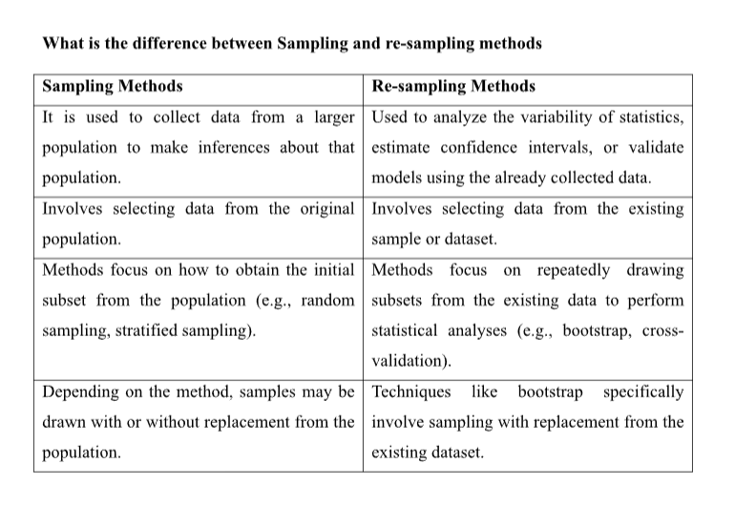

Central Tendency

Graphical techniques for organizing and displaying data allow the researcher to make some general observations about the shape and spread of the data, a more complete understanding of the data can be attained by summarizing the data using statistics. It will deal with measures of central tendency, measures of variability, and measures of shape. The computation of these measures is different for ungrouped and grouped data.

Central Tendency is the extent to which the values of a numerical variable group around a typical or central value. Most variables show a distinct tendency to group around a central value.

When people talk about an “average value” or “middle value ” or “most frequent value ”, they are unfortunately talking about mean, median and mode -three measures of the central tendency.

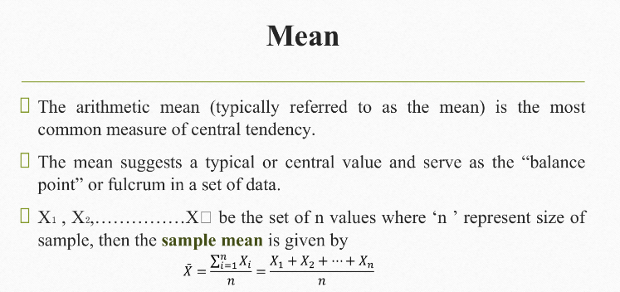
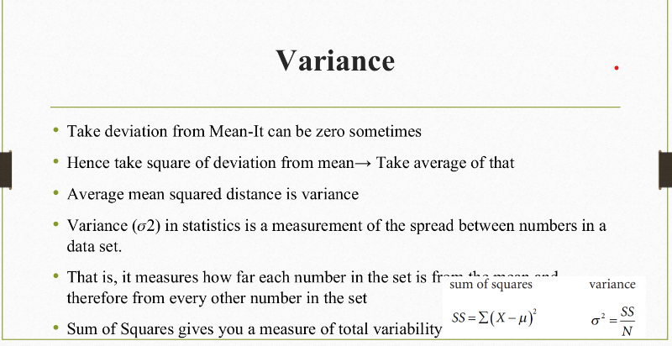
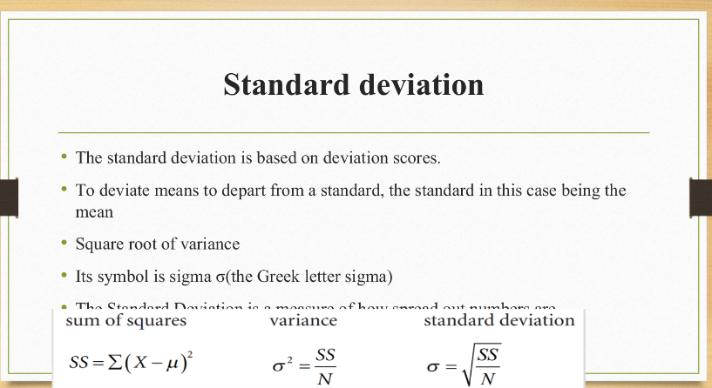
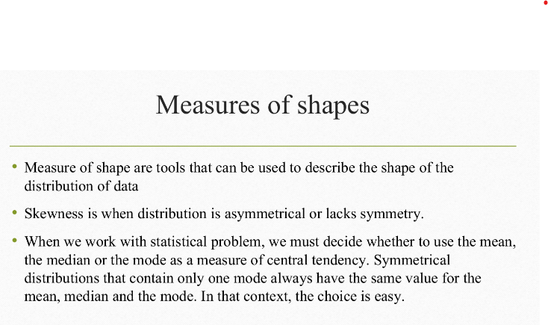
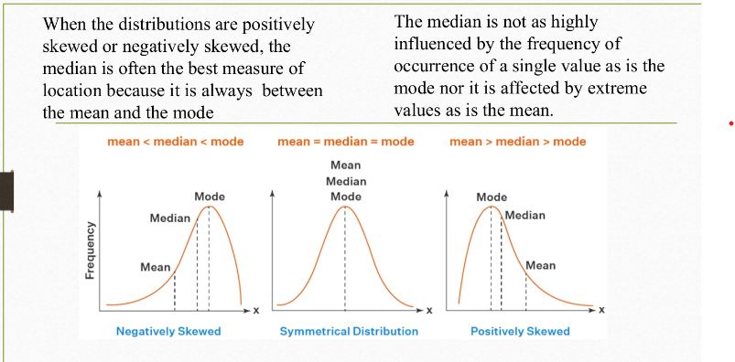

Correlation

Correlation is a measure that determines the degree to which two or more random
variables move in sequence.

Movement of one variable causes movement of other variable variables
Correlated.

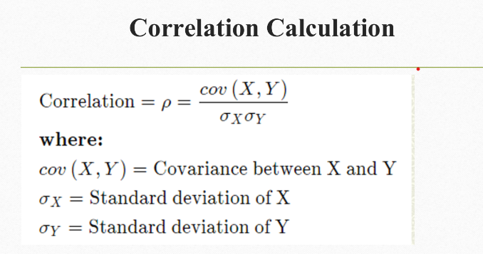

If the correlation is 1, they move perfectly together.

If the correlation is -1, the variables move perfectly in opposite directions.

If the correlation is 0, then the two variables move in random directions from each other

